Consumer Application Guide

# 1. Summary

The consumer application is used by Consumers, who are interested in purchasing products that have been tracked by Producers. The consumer application allows a Consumer to scan a product’s QR code at a store, which send out a request and provide information about all transactions that have been made to the product.

# 2. Requirements

* Android 5.0 or newer
* Application size: 3.09MB
* Internet connection
* Caching server running

## 2.1 Permissions

* android.permission.INTERNET

# 3. Installation Guide

1. Open ConsumerApp project in Android Studio

2. Update the VALIDATE_ACCOUNT variable to reflect the NXT address that will be validating the QR codes.

3. Update the CACHING_SERVER variable to reflect the address of the caching server.

4. Run the application to install it to the Android device.

# 4. Display Sequence

Step 1. Open the application and press the button ‘Scan Product’.

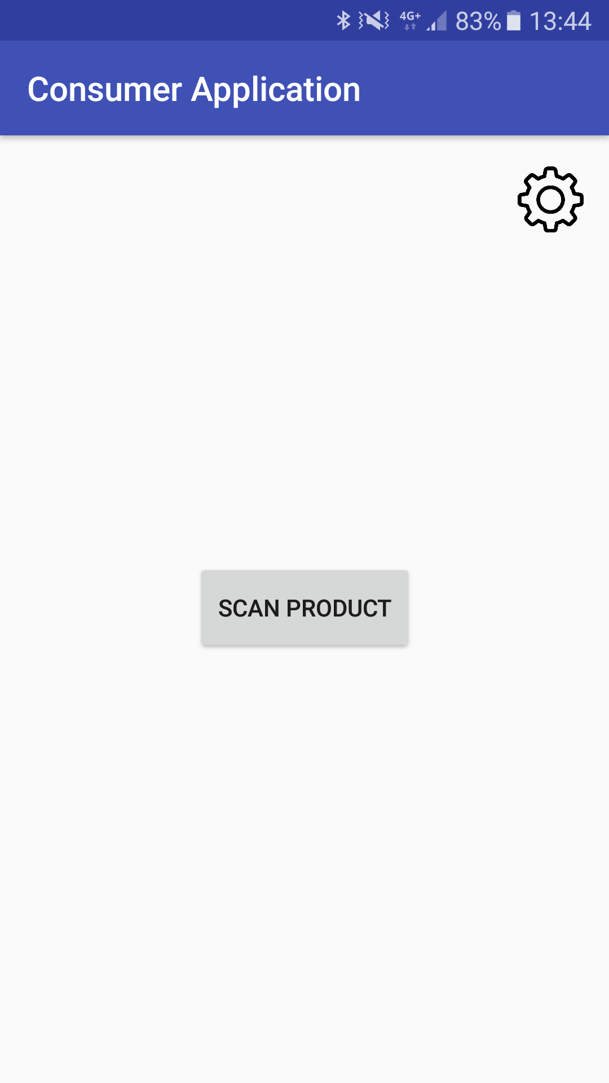

Step 2. Scan the barcode on the product.

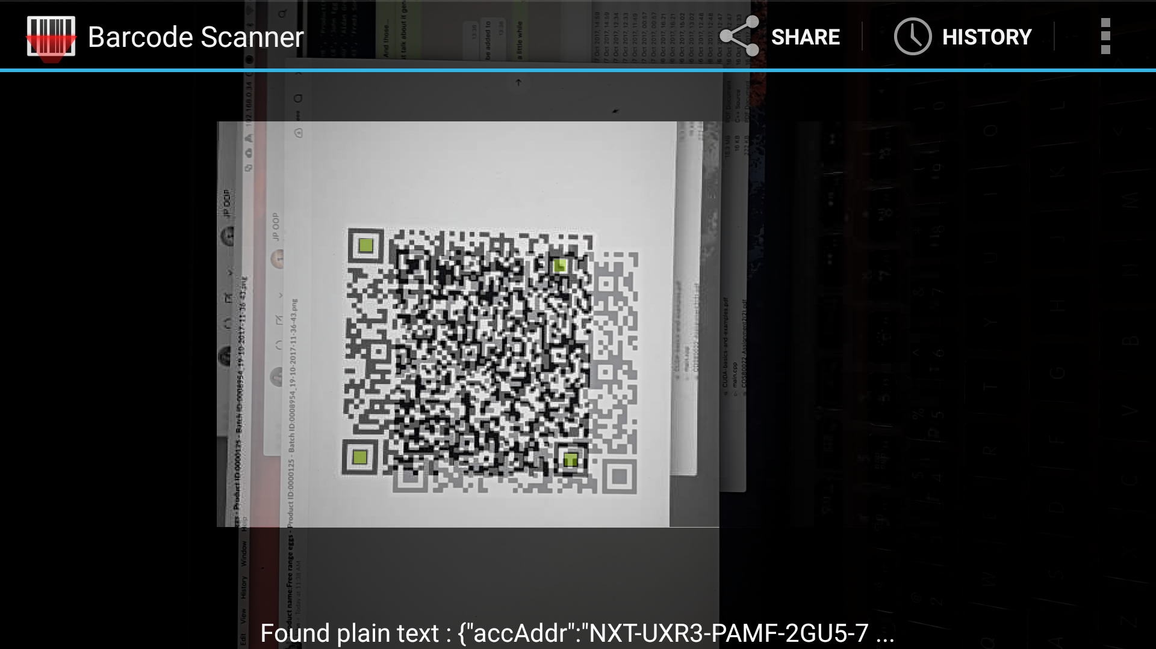

Step 3.

The information screen will display all information about the transactions to the product.

